Digital Lock System Project

Carl H. Jules and Alex Rodriguez

Florida Atlantic University

Author’s Note

Carl H. Jules and Alex Rodriguez, Department of Engineering, Florida Atlantic University.

This project was completed for a final exam for CDA 3331C, within a one week time frame.

Any correspondence regarding this project should be addressed to Dr. Ravi Shankar, Professor at the College of Engineering and Computer Science, Florida Atlantic University, Boca Raton, FL 33431.

Contact: shankar@fau.edu

Abstract

This report will discuss the development of a digital lock system using the microprocessor MS4302553, a 4x3 keypad, an LCD display and a solenoid. This system provides an insight about how an electronic lock works using a keypad to authenticate a door lock without the need of a physical key. The code used for this project was originally design using Energia 18 (aka Energia 1.6.10E18), but then was transferred and continued using Code Composer 6.1.3. In order to make the digital lock work efficiently, changes had to be made to the overall design of the schematics, which were provided by Cem Ünsalan and H. Deniz Gürhan “*Programmable Microcontrollers with Applications MS430 Launchpad with CCS and Grace”* (2014) on page 410. Our team was able to overcome the difficulties and created a fully functional digital lock system.

*Keywords*: Digital lock system, MSP430, Solenoid, 44

Digital Lock System Project

In many occasions, keeping something hidden or secure may seem to be a difficult task. We live in a time that creates many different technologies that make it a hassle to hide or keep something safe. However, as technologies keep advancing to disrupt or steal someone’s personal things, the technologies that keep those things safe also get better. An example of this, are electronic locks that require authentication in order to lock or unlock the system. It can be argued that the most common form of electronic lock utilizes a keypad to input a numerical code or password to obtain access or entry. Typically the combination length is set by the user and can be anywhere between 4 – 6 digits of length. This project was modeled after the electrical lock system described previously using an MSP430 microcontroller. The Texas Instruments MSP430™ family allowed for a less complex and more durable system to be created. Its relative low power consumption made it feasible to produce enough power for the solenoid and digital display which consumed the majority of the power. According to Texas Instruments, the “16-bit registers, and constant generator contributes to maximum code efficiency”, which allowed us to create a more efficient code using the provided materials (p. 1). In addition, our project also contains a digital display which assists the user to identify which action is being completed, either locking and resetting or unlocking and changing the password. Furthermore, our lock system includes two transducers wired as buzzers that simulate an alarm system, which only activate when the password has been inputted right or wrong. In the following sections of the project, we will discuss in detail each of the components used in this project and methods used to make the digital lock system function properly.

# Methods

Following is a list of the equipment to be used in this application:

• One 12-V dc adaptor

• One LM7805 voltage regulator

• One 16×2 character LCD (with a Samsung processor)

• One 10-kΩ potentiometer

• Two LEDs (green and red)

• Two 330-Ω resistors

• One solenoid

• One ULN2003

• Two buzzers

• One 4×3 keypad

• One push button

Schematic:

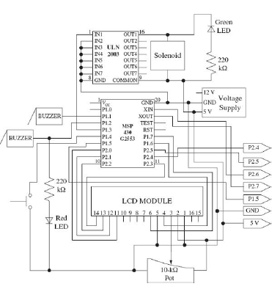 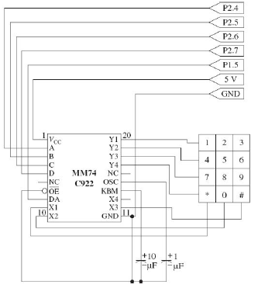

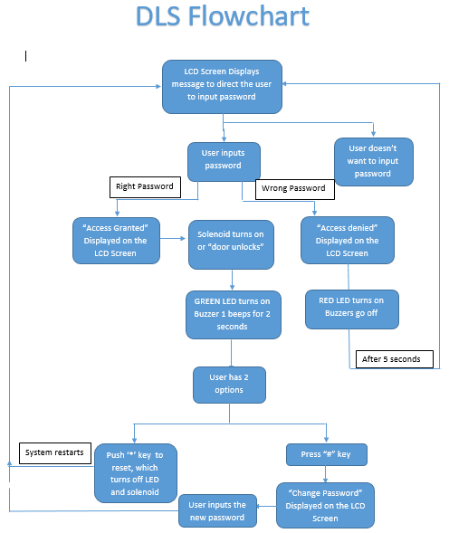

**Discussion**

This project was a worthy challenge which helped us understand the challenges we may face as an engineer causing us to reconsider original ideas and schematics. One may not always be correct the first time around and will often need to redraw everything on the board to accommodate the new desired needs and material or budget.

We were first unable to obtain an encoder and a solenoid from our parts room which we ordered online setting us back a week. Once all the parts were assembled, we had to do research on the transducer given to us to convert to a buzzer. The schematic for the buzzer was not as challenging to build and put together considering we needed to get more parts. We then faced the challenge of finding the correct schematic for the encoder since the one we received from our order was the 18-pin rather than the 20-pin encoder. Not having had experience using a voltage supplier such as the one in the schematic or a 10 K pot, we had to do more research on how to go about connecting those pieces on our board without damaging everything. Prior to making all of the required connections, we attached 3 breadboards making an educated guess on the amount of space required by all of our parts. We then connected our ground and power lines to have connections all throughout our board not realizing we needed a 5 V output to the LCD and solenoid connected to the 5 V supplier. We learned of such error when the LCD would not display properly since the MSP 430 provides 3.5 Volts only; we fixed that error by running a wire from TP1 near the USB port of the microprocessor which would provide the necessary voltage required. We did accidently overheat the voltage supplier by not grounding it on the board and noticed by the strong burning smell and hot surface of the supplier.

We made certain alterations to the schematic when it came time to program since these parts did not accommodate our level of programming. We noticed the switch could be connected to the RST pin rather than P1.4 because we needed more pins if we would run the keypad straight to the microprocessor rather than the encoder which we weren’t sure how to integrate in our code. The encoder was primarily put in the schematic because the author realized there would be a shortage of pins but our MSP 430 allowed us bypass that issue. Our parts personnel advised using an IC2 for the LCD to minimize the usage of pins as well but that process would have taken far too much time from a programming perspective. We later noticed how dim the LED’s were due to the size of the resistors shown on the schematic which were also changed.

We faced challenges from a programming perspective due to the shortage of libraries for the LCD display or keypad and headers in Code Composer Studio which is why we downloaded and started programming using Energia. Energia also sped up the process when testing since it automatically built and compiled the program onto the microprocessor although it felt short by not allowing one to debug accordingly to see the ports. Having the algorithm prior to programming also helped a lot in terms of understanding which parts needed more attention when writing the program and in what order. We had issues with outputting the numbers on the correct line while the “Enter Password” message was displayed on the first line of the LCD. We then ran into the error of not rotating or incrementing the row to display the next value on the LCD which replaced the previous value put in during testing. We had to look up the schematic for 4 by 3 LCD keypads and even unpeeled it to get an idea of which strings were the rows and columns as shown in one of our images.

## Limitations.

Our limitations mainly came in programming the project to work as we intended.

### Software limitations.

Software limitations were in Code composer not obtaining the liquid crystal display header which made us import or Energia file which had that library.

#### Hardware limitations.

#### Hardware limitations lied in not having enough pins at first to connect all of the keypad outputs until we realized we could use the RST pin for resetting our program.

##### **Time limitations.**

##### Due to parts needing to be ordered, we were limited in time to finish our project prior to our presentation in addition to the programming which played a vital part of our project.

References

*Electronics, Jameco. "MG Electronics Transducer." Www.Jameco.com ✦ 1-800-831-4242 (n.d.): n. pag. MG ELECTRONICS TRANSDUCER. Jameco. Web. 12 Dec. 2016.*

*K. (2012). Keypad library - Energia - MSP. Retrieved December 14, 2016, from http://forum.43oh.com/topic/3089-keypad-library*

*MSP430G2x53 Automotive Mixed-Signal Microcontrollers*. Texas Instruments, 01 Mar. 2014. Web. 10 Dec. 2016.

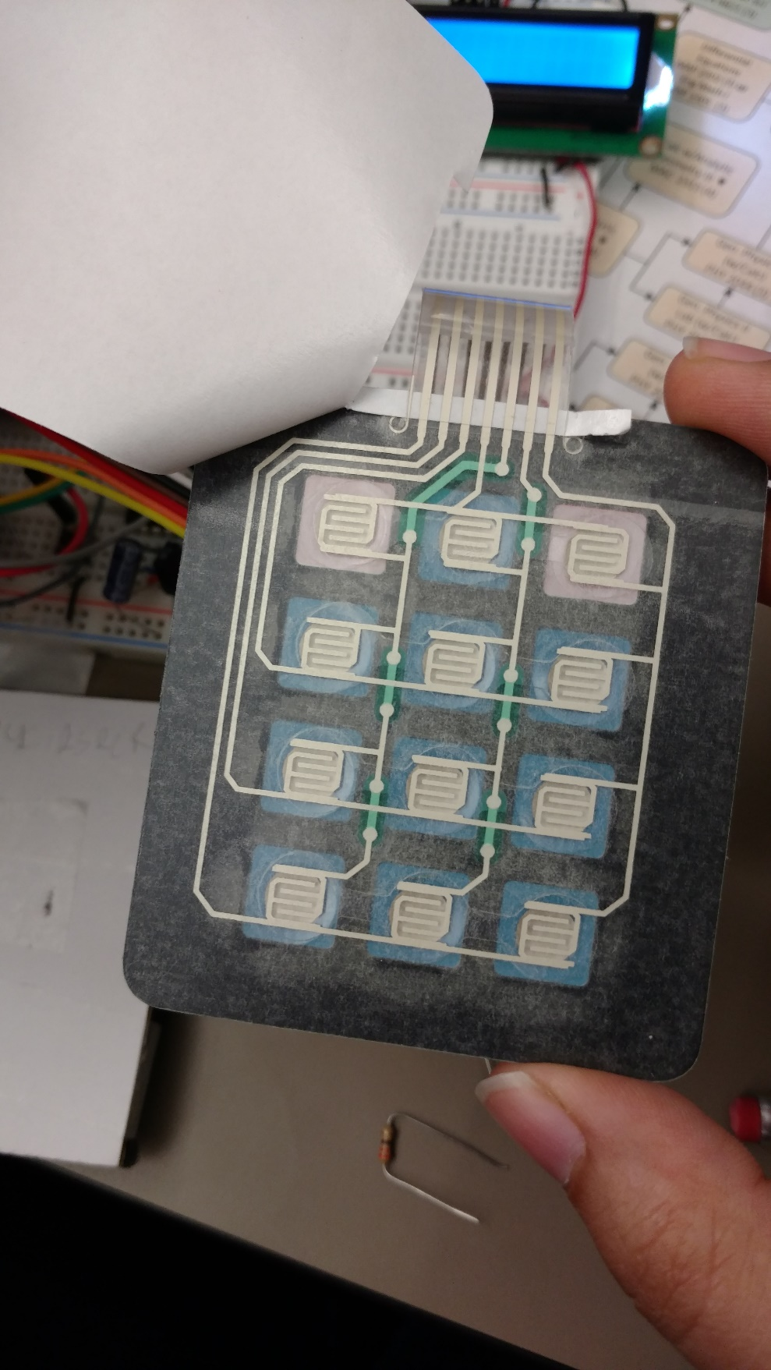 Figures title:

Figure 1Keypad Rows & Columns

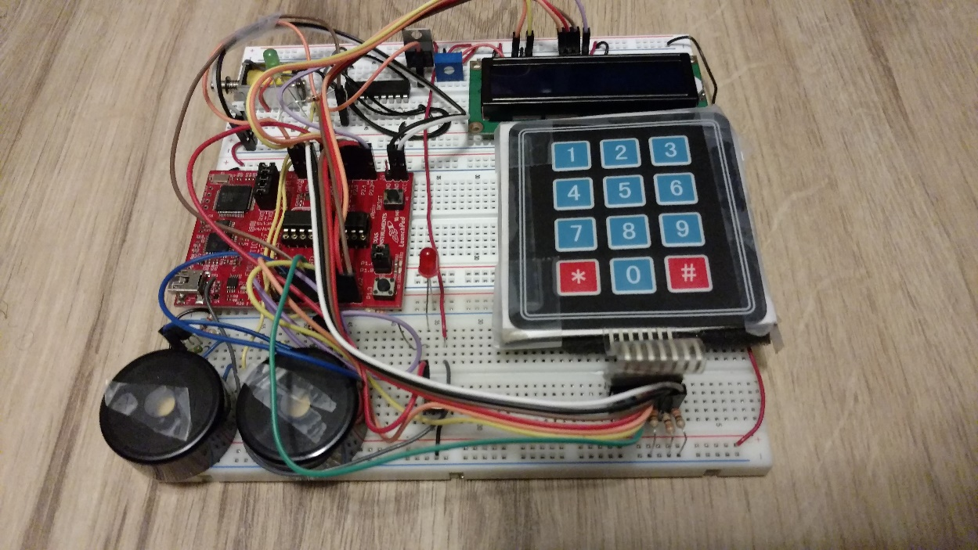

Figure 2 Buzzers(Left) with one RED LED

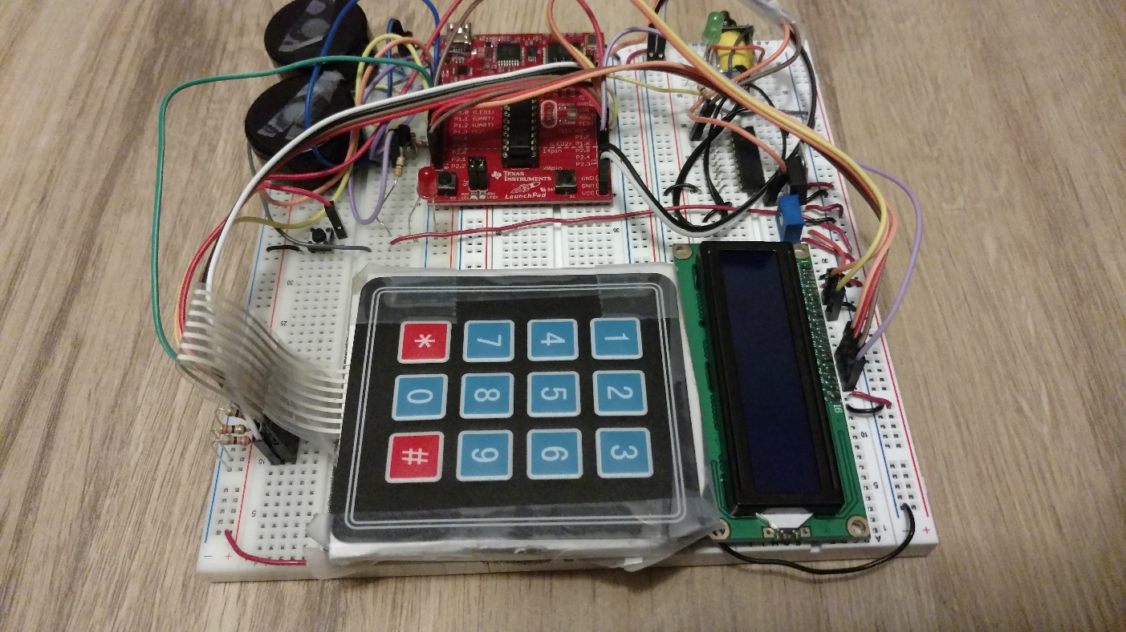

Figure 3 4X3 Keypad on left with LCD on the right.

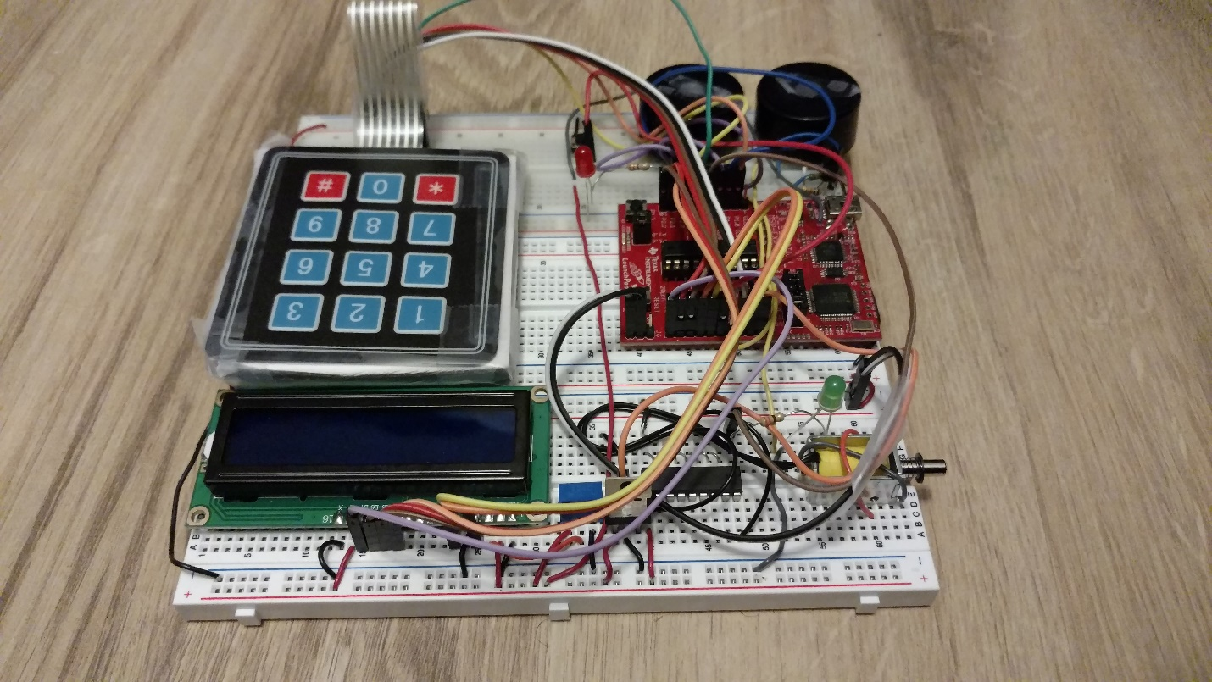

Figure 4 Solenoid onth right handside with Green LED

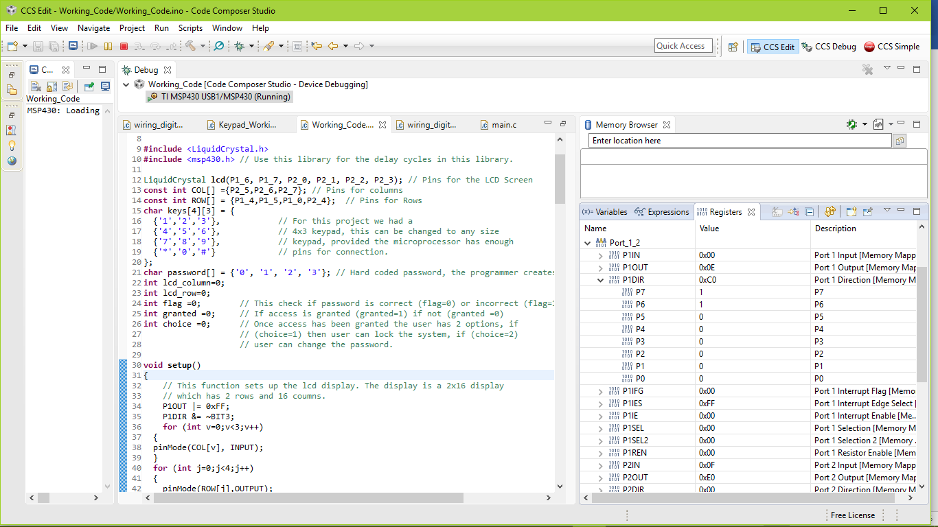

Prior to Password being input by user

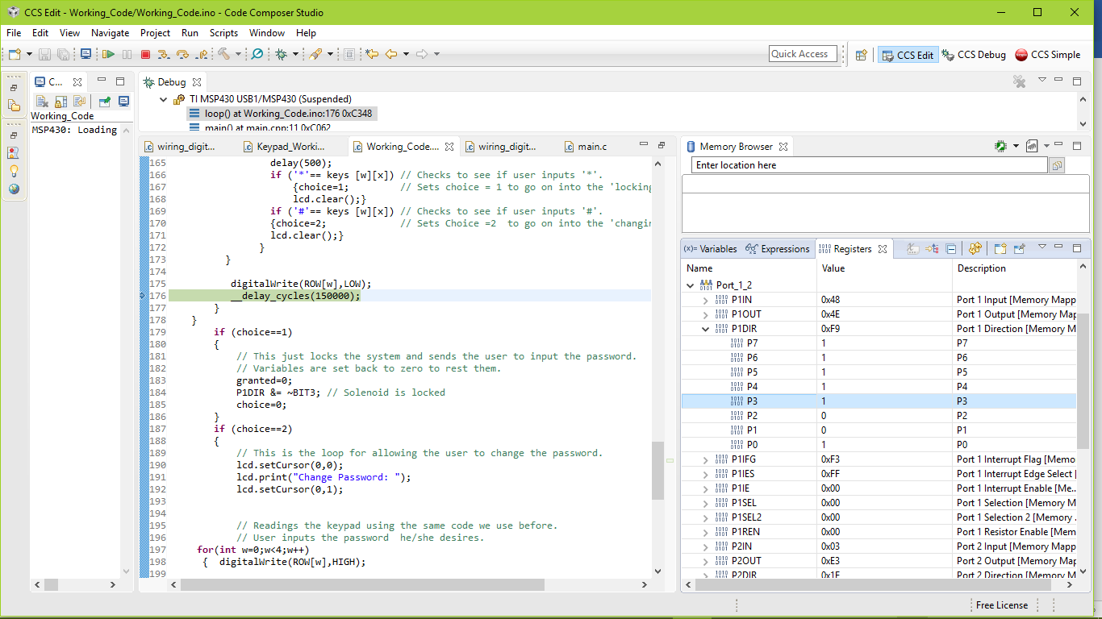

P3 is high since the correct password is entered by the user giving power to the solenoid and unlocking the door while the green LED turns on. P2 & P1 are off as the buzzers.

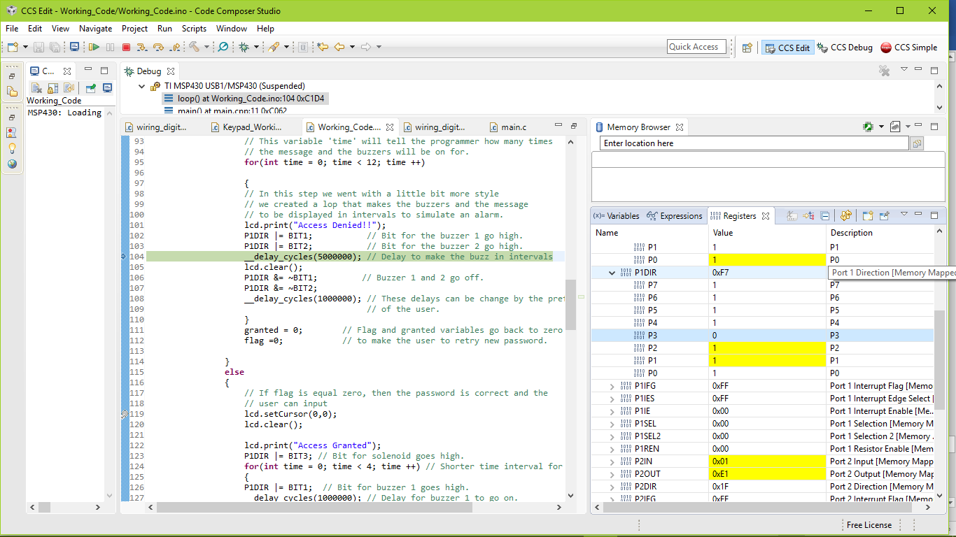

P2 and P1 are high as the buzzers go off showcasing the wrong password was entered by the user.

<https://youtu.be/zNbsNregsBI>